Town of Youngsville
Board of Commissioners
P. O. Box 190 / 134 US 1A South
Youngsville, NC 27596
(919) 925-3401 – Town Hall / (919) 925-3402 – Fax
CustomerService@TownofYoungsville.org www.townofyoungsville.org

MINUTES

BOARD OF COMMISSIONERS

FEBRUARY 11, 2021
7:00PM

REGULAR MEETING
YOUNGSVILLE COMMUNITY HOUSE

Mayor Fonzie Flowers called the Board Meeting of the Town of Youngsville Board of Commissioners to order at 7:00pm. Commissioner Hedlund gave invocation. In attendance were Commissioners Cat Redd, Terry Hedlund, Scott Brame, Larry Wiggins, and Joseph Johnson. Others in attendance were Town Administrator Phillip Cordeiro, Town Clerk / Tax Collector Emily Hurd, Police Chief Greg Whitley, Attorney Katie Barber-Jones (teleconference), Parks and Recreation Director Andrew Smith, Public Works Supervisor Randy Smith, Planning Director Erin Klinger, and ABC Board Chairman Rick Houser.

MOTION: TO APPROVE THE AGENDA

The motion was made by Commissioner Hedlund and was seconded by Commissioner Brame. The motion passed unanimously.

The next item on the agenda were Public Hearings. The first Public Hearing was for Annexation Petition 2021-2, Marshall Wiggins for property located at 2468 Cedar Creek Road. Mayor Flowers opened the Public Hearing at 7:01pm. Klinger clarified the location of the property at the intersection of Cedar Creek Road and Hicks Road. She explained Michael Hurt approached the Town regarding building an apartment complex and annexation of the property.

Cordeiro polled all teleconference participants and there were no comments from the public. Hurd stated no one had registered to speak. Mayor Flowers closed the Public Hearing at 7:02pm.

The second Public Hearing was for Annexation Petition 2021-3 - Wiggins Village, Phase 2 on Hicks Road. Mayor Flowers opened the Public Hearing at 7:02pm. Cordeiro polled all teleconference participants and there were no comments from the public. Hurd stated no one had registered to speak. Mayor Flowers closed the Public Hearing at 7:03pm.

The next item on the agenda was citizens’ comments. Due to the social distancing restriction for the COVID-19 Virus, citizens attended via web/teleconference.

Hurd stated no one had registered to speak. Cordeiro polled all teleconference participants and there were no comments from the public.

The next item on the agenda was the approval of the Consent Agenda. The Consent Agenda consisted of:
  - Minutes from the Regular Board Meeting – January 14, 2021
  - Finance Report
  - Fire Department Report
  - Parks and Recreation Report
  - Planning and Zoning Report
  - Police Department Report
  - Public Works Report
  - Tax Collector’s Report
  - Tax Release – William Jason Pearce - $11.15 – Out of Town
  - Budget Amendment – Capital Project Expenditures

MOTION: TO APPROVE THE CONSENT AGENDA

The motion was made by Commissioner Brame and was seconded by Commissioner Redd. The motion passed unanimously.

The next item on the agenda was Old Business. The first item under Old Business was to adopt Annexation Ordinance 2021-2, Marshall Wiggins for property located at 2468 Cedar Creek Road.

MOTION: ADOPT ANNEXATION ORDINANCE 2021-2, MARSHALL WIGGINS, 2468 CEDAR CREEK ROAD

The motion was made by Commissioner Wiggins and was seconded by Commissioner Hedlund. The motion passed unanimously.

The second item under Old Business was to adopt Annexation Ordinance 2021-3 for Wiggins Village, Phase 2 on Hicks Road.

MOTION: ADOPT ANNEXATION ORDINANCE 2021-3, WIGGINS VILLAGE, PHASE 2 – HICKS ROAD

The motion was made by Commissioner Hedlund and was seconded by Commissioner Wiggins. The motion passed unanimously.

The next item on the agenda was New Business. The first item under New Business was to consider forgiveness of payables related to management services rendered by the Town to the Youngsville Board of Alcoholic Beverage Control. Cordeiro noted the management services agreement with the ABC Board expired in FYE 2020. He explained the calculation of minimum distributions the ABC Board had to pay to the Town based on General Statutes. On top of the minimum distributions owed to the Town, the ABC Board had contracted to provide the Town all additional profits. However, that agreement was in place when the ABC Board didn’t need the additional revenue. Cordeiro stated the ABC Board was in the process of opening an ABC Store at the Foodlion Plaza because of the growth in the area. He explained the ABC Board was requesting to keep the additional profit of $48,000 from FYE 2020 so they can use those funds towards opening the new ABC Store. Cordeiro noted the new ABC Store location will increase revenues, thus increasing the minimum distributions to the Town. He felt this was an excellent move.

MOTION: APPROVE RESOLUTION OF FORGIVENESS OF PAYABLES RELATED TO MANAGEMENT SERVICES RENDERED BY THE TOWN TO THE YOUNGSVILLE BOARD OF ALCOHOLIC BEVERAGE CONTROL

The motion was made by Commissioner Wiggins and was seconded by Commissioner Brame. The motion passed unanimously.

The second item under New Business was to schedule a Public Hearing to allow comment on amendments to Chapter Six of the Town Code of Ordinances (Solid Waste Management Program) and the amendments to the Town’s Fee Schedule. Cordeiro explained there were two proposals included in the agenda packet. He encouraged the Board to read and deliberate in advance of the Public Hearing. Cordeiro stated the point of the proposed amendments was to decide the Town’s direction on how to move forward with solid waste as it pertains to apartment complexes. Currently, apartment complexes are treated as commercial. He felt the purpose of the sanitation program included community appearance and safety. As it stands, commercial businesses are currently allowed to contract with vendors directly as business needs varied, including some needs the Town is currently unable to handle. However, Cordeiro noted that it was possible to bring service to apartment complexes in house. He explained it was still a residential need with the same type of waste, though the amount will vary. The apartment complexes will normally use a dumpster or compactor, but the Town will be able to take care of that. The question is, does the Town want to maintain the compactors or let the apartment complexes maintain the compactors themselves. Cordeiro noted the downside of having the apartment complexes maintain their services is that not all of them may do as good of a job as expected, though others may exceed expectations. He stated Code Enforcement would be able to take care of any problems but it’s not a situation the Town wants to be in as it creates complexity.

Cordeiro explained the roll carts will be brough in house for services, but the Town will still need to contract with a waste management service for the compactors. He noted the Town would still control how the compactors are serviced. Both ways of managing compactors have their pros and cons.

Cordeiro stated he drafted two versions revising the Code of Ordinances; one version leaves service up to the apartment complex and one version that provides the Town take over service with the apartment complex paying a per unit fee equal to the residential rate. He explained the garbage rate should be uniform across all residential accounts as the purpose of the fee is to take the entire costs of the service town wide and divide it equally amongst the residential accounts. Cordeiro noted other services were handled this way, such as policing that was paid with taxes.

Cordeiro stated he wanted to schedule a Public Hearing for next month with the hope of adopting the revisions in April or May. This will give the Town time to address any concerns and feedback.

Mike Hurt, co-owner of several apartment complexes in the area, explained in 2014 the Town changed the way apartment complexes were handled and gave the servicing responsibilities to the apartment complexes. His understanding was the Town did not want to get into the compactor business. Since 2014, compactors at apartment complexes have been maintained by the owners. Mr. Hurt stated there was an issue around Christmas that was brought to the Town’s attention but noted that problem has since been addressed. He stated there did need to be some sort of penalty should the Town not take over the compactors at apartment complexes. Penalties will help ensure the properties are well maintained. Mr. Hurt stated no one wanted a well-maintained property more than the owners, as they want to be able to rent the units and an appeasing community is important. The problems at Hampton Village have been addressed and he will speak more during the Public Hearing.

Cordeiro noted the only apartment complex currently in town is Hampton Village but more are being built soon. He wanted to get in front of this situation and set a policy that will apply to all potential owners of apartment complexes. Cordeiro explained both versions address issues regarding non-compliance, including penalties. As violations of solid waste rules are more of an immediate concern, the revisions curtail some of the appeals process.

MOTION: SCHEDULE PUBLIC HEARING FOR 7:00PM ON THURSDAY, MARCH 11, 2021

The motion was made by Commissioner Redd and was seconded by Commissioner Brame. The motion passed unanimously.

The third item under New Business was the presentation of Annexation Petitions; 2021-1 – Holden Creek Preserve, Phase 6 – Holden Creek LLC portion, 2021-4 – East Woods of Patterson, Phase 7 – Patterson Woods LLC and 2021-5 – Holden Creek Preserve, Phase 6 – Taylor Morrison Portion. Hurd presented the Annexation Petitions and explained the locations to the Board. She noted that Holden Creek Preserve, Phase 6 had two owners because some of the lots had been sold to a builder, Taylor Morrison.

The fourth item under New Business was to adopt the Resolutions directing Clerk to investigate a petition received under NCGS 160A-31; 2021-1 – Holden Creek Preserve, Phase 6 – Holden Creek LLC portion, 2021-4 – East Woods of Patterson, Phase 7 – Patterson Woods LLC, and 2021-5 – Holden Creek Preserve, Phase 6 – Taylor Morrison Portion.

MOTION: APPROVE THREE RESOLUTIONS DIRECTING CLERK TO INVESTIGATE PETITIONS RECEIVED UNDER NCGS 160A-31: 2021-1 – HOLDEN CREEK PRESERVE, PHASE 6 – HOLDEN CREEK LLC PORTION, 2021-4 – EAST WOODS OF PATTERSON, PHASE 7, PATTERSON WOODS LLC, AND 2021-5 – HOLDEN CREEK PRESERVE, PHASE 6 – TAYLOR MORRISON PORTION

The motion was made by Commissioner Brame and seconded by Commissioner Johnson. The motion passed unanimously.

The fifth item under New Business was the presentation of the Certificates of Sufficiency for annexations; 2021-1 – Holden Creek Preserve, Phase 6 – Holden Creek LLC portion, 2021-4 – East Woods of Patterson, Phase 7 – Patterson Woods LLC, and 2021-5 – Holden Creek Preserve, Phase 6 – Taylor Morrison Portion. Hurd noted she has verified the ownership of the newly sold property in Holden Creek Preserve, Phase 6. As all annexation petitions were for companies, she stated she has verified signatures of the company representatives.

The sixth item under New Business was to adopt Resolutions fixing date of a Public Hearing on question of annexations pursuant to NCGS 160A-31; 2021-1 – Holden Creek Preserve, Phase 6 – Holden Creek LLC portion, 2021-4 – East Woods of Patterson, Phase 7 – Patterson Woods LLC, and 2021-5 – Holden Creek Preserve, Phase 6 – Taylor Morrison Portion.

MOTION: APPROVE THREE RESOLUTIONS FIXING DATE OF PUBLIC HEARING FOR MARCH 11, 2021 ON QUESTION OF ANNEXATIONS PURSUANT TO NCGS 160A-31: 2021-1 – HOLDEN CREEK PRESERVE, PHASE 6 – HOLDEN CREEK LLC PORTION, 2021-4 – EAST WOODS OF PATTERSON, PHASE 7 – PATTERSON WOODS LLC, AND 2021-5 – HOLDEN CREEK PRESERVE, PHASE 6 – TAYLOR MORRISON PORTION

The motion was made by Commissioner Brame and was seconded by Commissioner Johnson. The motion passed unanimously.

The next item on the agenda was Reports and Other Business. Mayor Flowers congratulated Cordeiro on his upcoming fatherhood.

Mayor Flowers stated the litter was still rather bad and knows the subject has come up often. He didn’t know any way to fix the problem and wondered if the fines could be increased. Mayor Flowers stated it was also a problem catching the person littering. He noted the litter was horrible in all the areas surrounding town and was open to solutions.

Commissioner Hedlund stated he has met with local business owners and those areas have been discussed. They are looking to host a massive road cleanup on March 27th and hope to do this as an annual event. Commissioner Hedlund stated he knew this wouldn’t solve the problem. He noted the Franklin County Sheriff’s Office had an inmate program for road cleaning and since that program stopped, the situation had worsened. Commissioner Hedlund inquired if they could meet with Sheriff Winstead to start the program again.

Mayor Flowers applauded the effort by Commissioner Hedlund and the Kiwanis Club to keep the town clean. He noted the areas in the ETJ outside of town limits were in bad condition and it has been an issue for a long time. Mayor Flowers stated he was open to suggestions on how to best curb the problem. Commissioner Hedlund stated he would prefer to meet with Sheriff Winstead instead of sending a request by letter and Mayor Flowers stated he would be open to meeting with the Sheriff as well. Cordeiro stated Chief Whitley could engage Sheriff Winstead about inmate labor, noting the Sheriff was an excellent partner of the Town. He noted the local Chiefs and the Sheriff met regularly and felt this was a good idea for all the municipalities to participate in.

Cordeiro thanked everyone for their well wishes and the Board’s support. He expressed his appreciation to the Board for their support, which allowed him to get the right team assembled. Cordeiro stated the Town is doing great things for the community and he had confidence in the Town’s Staff during his absence. He noted the Board could reach out to any of the Department Heads should they need help or information.

Cordeiro noted the Public Works facility was progressing, with a June target date. The Main Street Improvements Project (MSIP) was also on target. He stated the Franklin County Board of Commissioners would approve the final agreement for the utility work Franklin County would complete during the project. Cordeiro stated he will keep the Board informed as they move forward.

Commissioner Hedlund noted Grace Haven Church has adopted Hicks Road and they were able to clean it this month. He stated David Jerose was working with the Wake Forest Kiwanis Club to do a citywide event between Wake Forest and Youngsville to clean the roads.

Commissioner Johnson stated the access road to Luddy Park from Holden Road had ruts in it from the trucks that were being driven on it. With all the rain, it has created some major problems. He felt that area needed to have the pavement extended.

Commissioner Brame stated the Northeast Area Study (NEAS) update was coming to an end. He stated there was a virtual event on Monday. This event will allow a virtual walkthrough and participants will be allowed to go to different stages. The maps will be interactive and there will still be time for the public to make further comments. Cordeiro stated the website was NEASupdate.com and noted the NEAS also included plans for more than just traffic, such as bike trails, pedestrian trails, and greenways.

Cordeiro stated he had nothing to add to Patton-Motluck’s Financial Report.

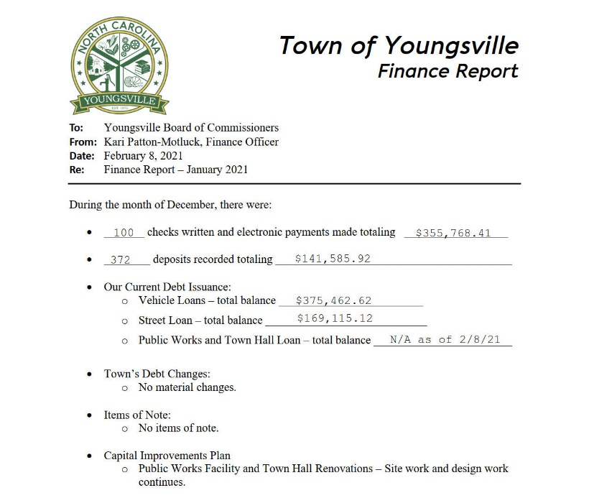

Mayor Flowers noted the Youngsville Fire Department’s Annual Report was included in the agenda packet. He stated they have done a great job and appreciated all they do for the community.

At the bottom of his report, R Smith noted there were projects regarding trimming the trees at the Mitchell Park. He explained he had reached out to arborists and will update the Board next month on the progress.

A Smith stated he had nothing to add to the Parks and Recreation Report.

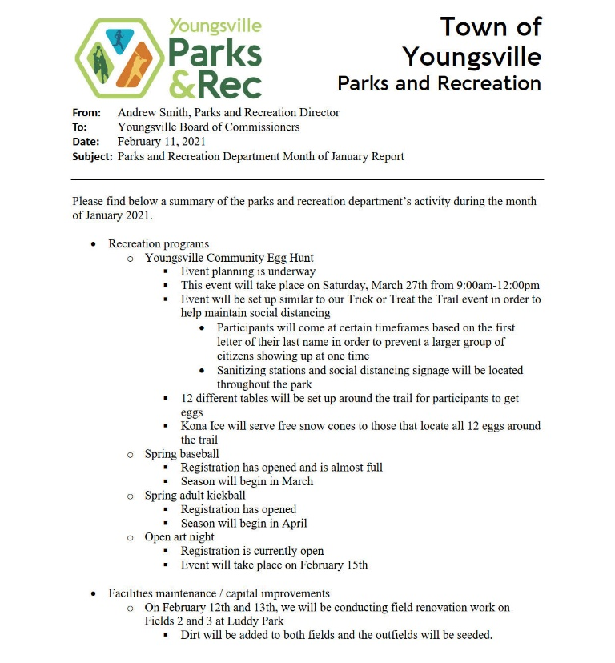

Klinger stated she had nothing to add to the Planning and Zoning Report.

Chief Whitley stated he had nothing to add to the Police Department Report.

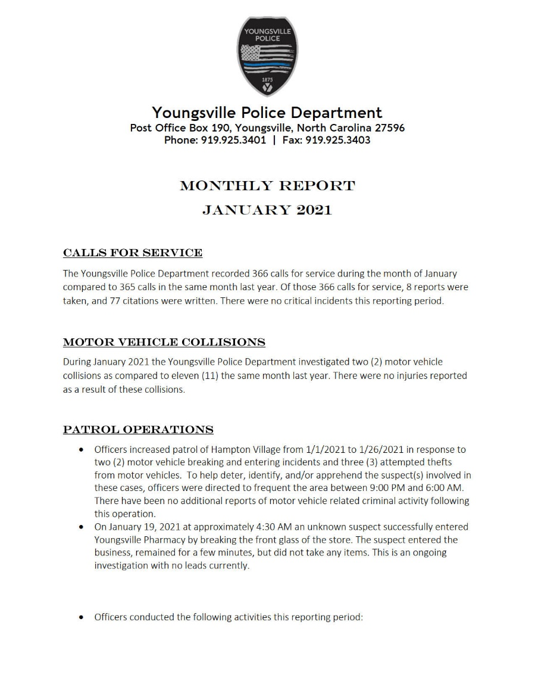
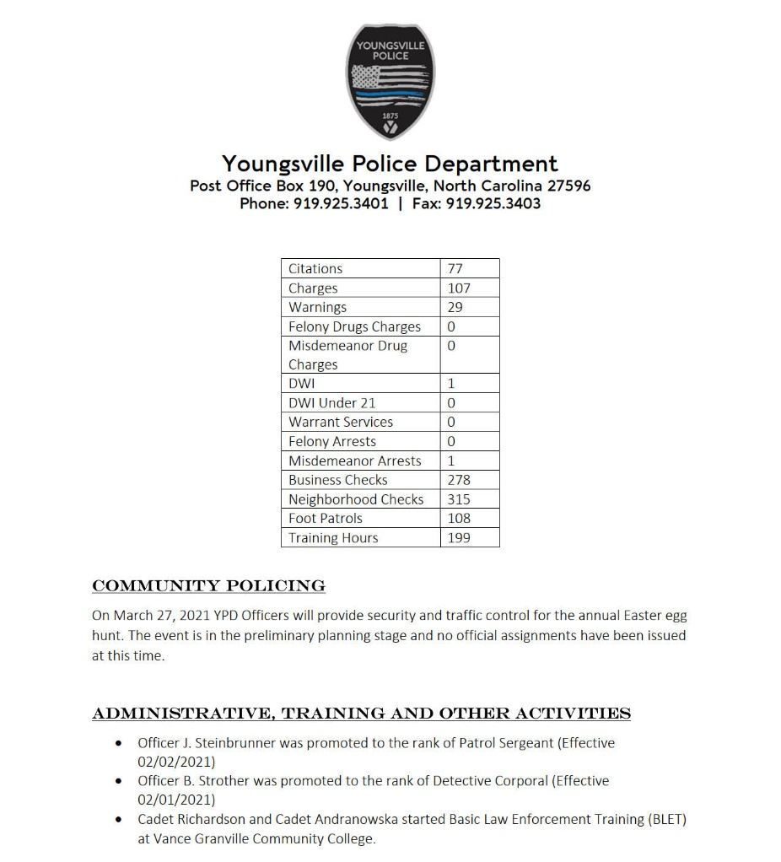

Attorney Barber-Jones stated she had nothing to report at this time.

Hurd updated the Board on the expiration dates for ABC Board Member terms. She explained recent research showed the expiration dates for Member terms should be based on the creation of the ABC Board and not the date a Member was appointed. As for the two newly added seats, they will continue to have expiration dates based on the expansion of the ABC Board. Hurd stated she has adjusted expiration dates accordingly, noting this changed Chairman Houser’s expiration from February to June of this year. She noted his re-appointment, should he choose to continue, will appear on the May agenda.

Hurd stated there were still two vacancies on the ABC Board. She explained with the adjusted expiration dates, these two terms will expire in approximately a year and a half. Hurd hoped this would help draw in volunteers who want to try serving on an advisory board but weren’t sure about a 3-year term.

Hurd stated she would be in Clerk School the following week and will return all calls and emails when possible.

Hurd stated she had nothing to add to the Tax Collector’s Report.

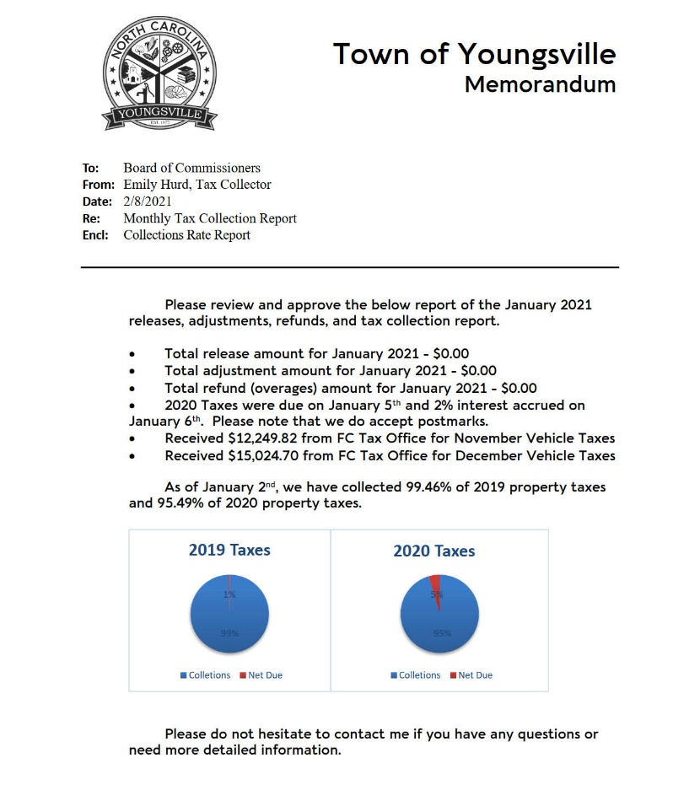

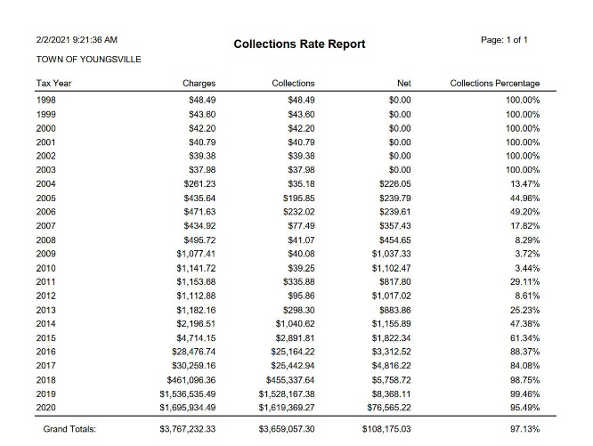

Mayor Flowers stated the Board had no need to go into Closed Session

The meeting adjourned at 7:37pm upon a motion made by Commissioner Wiggins, seconded by Commissioner Brame, and approved unanimously.

